

School of Computing

Department of Artificial Intelligence and Machine Learning

DATA ANALYSIS ESSENTIALS
CERTIFICATE

This is to certify that the Cornerstone project work entitled “WEB SCRAPING AND PRODUCT PRICE ANALYSIS” is submitted by

A.YASHWANTH(26B21AI006)
B.GOPI PAVAN(26B21AI009)
B.VENKATESH(25B11AI136)

in partial fulfilment of the requirements for the award of the B.Tech. degree in Artificial intelligence and machine learning the academic year 2026-2027.

Project Guide Head of the Department
ADDAKULA CHAITHANYA Dr. K. Naga Bhargavi, Ph.D,
, Assistant Professor, Associate Professor & HOD
Department of AIML Department of AIML

DECLARATION

We hereby declare that the project entitled “WEB SCRAPING AND PRODUCT PRICE ANALYSIS SYSTEM” is our original work and is submitted to ADITYA UNIVERSITY, Surampalem, in partial fulfillment of the requirements for the award of the B.Tech. degree in Artificial Intelligence and Machine learning-
We further declare that this project work has not been submitted, either in full or in part, for the award of any degree or diploma in this or any other institution. We also confirm that this work has been carried out with academic honesty and complies with the Institutional Academic Integrity and AI Usage Policy.
Place:
Surampalem
Date:
By
B.GOPI PAVAN (26B21AI009)
A.YASHWANTH(26B21AI006)
B.VENKATESH(25B11AI136)
03-04-2026

ACKNOWLEDGEMENT

It is with immense pleasure that we express our sincere gratitude to our Cornerstone Project Guide, Alamanda Sophia, Assistant Professor, who has guided us throughout the project. Her valuable support, encouragement, and guidance have greatly contributed to the successful completion of this work.
We would like to thank our Deputy Heads of the Department, Dr. Bollu Manikyala Rao, Associate Professor and Dr. Dasari Veeraswamy, Assistant Professor, Department of AIML, for their support and valuable suggestions.
Our deepest thanks to our Head of the Department, Dr. Kovvuri N Bhargavi, Associate Professor & HOD, for her inspiration and for providing all the necessary facilities and resources required for this project.
We also extend our sincere thanks to Dr. M.V. Rajesh, Associate Dean, School of Computing, for his encouragement and support during our project.
We would like to express our sincere gratitude to Dr. G. Suresh, Registrar; Dr. A. Ramesh, Pro Vice-Chancellor (Engineering & Sciences); Dr. S. Rama Sree, Pro Vice-Chancellor (Academics); Dr. M.B. Srinivas, Vice-Chancellor; and Dr. M. Sreenivasa Reddy, Deputy Pro Chancellor and Management, Aditya University, for providing excellent infrastructure and state-of-the-art laboratories.
Finally, we would like to thank the faculty members, lab technicians, non-teaching staff, and our friends who have directly or indirectly supported us in completing this Cornerstone project successfully.

ABSTRACT
This project presents a data analysis study of COVID-19 cases using a country-wise dataset containing 187 countries/regions and 15 attributes. The dataset includes confirmed cases, deaths, recoveries, active cases, newly reported cases, newly reported deaths, newly reported recoveries, case and recovery rates, previous-week confirmed cases, one-week change, one-week percentage increase, and WHO region. The analysis focuses on data understanding, preprocessing, descriptive statistics, exploratory data analysis and visualization. The dataset contains 16,480,485 confirmed cases, 654,036 deaths, 9,468,087 recovered cases and 6,358,362 active cases in total. Visualizations are used to compare countries and WHO regions and to identify differences in case burden, deaths, recoveries and recent weekly growth. The project demonstrates how structured data analysis can convert raw public-health records into clear numerical and visual insights.

Table of contents

S.No. | Contents | Pages
CHAPTER :1 | Introduction
1.1 | Introduction to the Project
1.2 | Problem Statement
1.3 | Objectives of the Project
1.4 | Scope of the Project
CHAPTER :2 | Dataset Description and Understanding
2.1 | Dataset Source
2.2 | Dataset Description
2.3 | Features / Attributes
2.4 | Target Variable
2.5 | Dataset Statistics / Initial Exploration
CHAPTER :3 | Data Preprocessing
3.1 | Data Collection / Loading
3.2 | Handling Missing Values
3.3 | Handling Duplicate / Inconsistent Data
3.4 | Feature Scaling
3.5 | Standardization
3.6 | Label Encoding
3.7 | One-Hot Encoding
3.8 | Project-Specific Preprocessing
CHAPTER :4 | System Design and Methodology
4.1 | Proposed Methodology
4.2 | System Workflow / Architecture
4.3 | Flowchart
4.4 | Tools and Technologies Used
4.5 | Algorithm / Model Used
CHAPTER :5 | Implementation
5.1 | Development Environment
5.2 | Dataset Loading and Exploration
5.3 | Preprocessing Implementation
5.4 | Exploratory Data Analysis
5.5 | Analysis Implementation
5.6 | Important Code Explanation
CHAPTER :6 | Data Visualization and Results
6.1 | Bar Graph
6.2 | Pie Chart
6.3 | Histogram
6.4 | Box Plot
6.5 | Line Chart
6.6 | Scatter Plot
6.7 | Project-Specific Visualizations
6.8 | Interpretation of Visualizations
CHAPTER :7 | Analysis of Results
7.1 | Evaluation Metrics
7.2 | Experimental Results
7.3 | Result Interpretation
7.4 | Discussion
CHAPTER :8 | Output Screenshots
9 | Conclusion and Future Enhancements
9.1 | Conclusion
9.2 | Limitations
9.3 | Future Enhancements
10 | References
11 | Appendix – Source Code

CHAPTER 1 – INTRODUCTION

1.1 Introduction to the Project
COVID-19 Data Analysis is a data-analysis project designed to study country-wise COVID-19 indicators. The project uses numerical records to understand the distribution of confirmed cases, deaths, recoveries and active cases. It also considers recent changes and WHO regional grouping. The main purpose is to clean, summarize and visualize the dataset so that important patterns can be understood easily.

1.2 Problem Statement
Raw COVID-19 records contain multiple numerical attributes for many countries. Directly examining all rows makes comparison difficult. The problem is to organize the data, check its quality, calculate useful summaries, compare countries and regions, and present the findings through suitable visualizations.

1.3 Objectives of the Project
- Load and understand the COVID-19 country-wise dataset.
- Check data types, missing values and duplicate records.
- Perform basic preprocessing and prepare the data for analysis.
- Calculate descriptive statistics and identify high-value countries and regions.
- Analyze confirmed cases, deaths, recoveries, active cases and weekly changes.
- Create visualizations such as bar charts, histograms, box plots and scatter plots.
- Interpret the visual results in a simple and understandable manner.

1.4 Scope of the Project
The scope is limited to analysis of the supplied dataset. It covers descriptive and exploratory analysis of the available country/region records and does not attempt to predict future outbreaks or establish medical causation. The results represent the values contained in the supplied dataset.

CHAPTER 2 – DATASET DESCRIPTION AND UNDERSTANDING

2.1 Dataset Source
The project uses the dataset supplied for the DAE project as the primary data source. The file contains country/region-level COVID-19 indicators together with WHO regional classification. No external data has been added to the analysis.

2.2 Dataset Description
The dataset contains 187 rows and 15 columns. There are 6 WHO regions represented.

2.3 Features / Attributes
Attribute | Description | Type
Country/Region | Country or region name | Categorical
Confirmed | Total confirmed cases | Numeric
Deaths | Total deaths | Numeric
Recovered | Total recovered cases | Numeric
Active | Active cases | Numeric
New cases | Newly reported cases | Numeric
New deaths | Newly reported deaths | Numeric
New recovered | Newly reported recovered cases | Numeric
Deaths / 100 Cases | Deaths per 100 confirmed cases | Numeric
Recovered / 100 Cases | Recovered cases per 100 confirmed cases | Numeric
Deaths / 100 Recovered | Deaths relative to recovered cases | Numeric
Confirmed last week | Confirmed cases in the previous week | Numeric
1 week change | Change in confirmed cases over one week | Numeric
1 week % increase | Percentage increase over one week | Numeric
WHO Region | WHO regional classification | Categorical

2.4 Target Variable, if applicable
This is an exploratory data-analysis project rather than a supervised machine-learning prediction task. Therefore, no single target variable is required. Confirmed cases, deaths, recoveries, active cases and weekly increase are treated as analysis measures.

2.5 Dataset Statistics / Initial Exploration
Measure | Value
Number of records | 187
Number of attributes | 15
WHO regions | 6
Total confirmed cases | 16,480,485
Total deaths | 654,036
Total recovered cases | 9,468,087
Total active cases | 6,358,362
Total new cases | 228,693
Total new deaths | 5,415
Total new recoveries | 174,623

The country with the highest confirmed-case count in the supplied dataset is US with 4,290,259 confirmed cases. The highest deaths value is also recorded for US with 148,011 deaths. The highest recovered count is recorded for Brazil with 1,846,641 recoveries.

CHAPTER 3 – DATA PREPROCESSING

3.1 Data Collection / Loading
The supplied data file was loaded as a tabular dataset. The first row was treated as the column header. Numeric COVID-19 measures were retained as numeric variables and country/region and WHO Region were treated as categorical variables.

3.2 Handling Missing Values
The supplied dataset contains 0 missing cells across the 187 records and 15 columns. Therefore, no missing-value imputation was required for the supplied data.

3.3 Handling Duplicate / Inconsistent Data
Exact duplicate rows detected in the supplied dataset: 0. Duplicate removal was therefore not required.

3.4 Feature Scaling
Feature scaling is not required for the descriptive visualizations used in this project because the project does not train a distance-based or gradient-based predictive model.

3.5 Standardization
Standardization is not applied because the main objective is descriptive analysis of the original COVID-19 measures, where retaining their original units improves interpretation.

3.6 Label Encoding
Label encoding is not necessary for the main analysis because categorical columns are used mainly for grouping and labeling visualizations.

3.7 One-Hot Encoding
One-hot encoding is not required because no machine-learning model is trained in this version of the project.

3.8 Other Project-Specific Preprocessing
Country/region and WHO Region were retained as categorical labels. Numeric columns were checked for appropriate numeric types. Aggregations were then performed at country and WHO-region level for comparison.

CHAPTER 4 – SYSTEM DESIGN AND METHODOLOGY

4.1 Proposed Methodology
- Load the supplied dataset.
- Inspect dimensions, column names and data types.
- Check missing and duplicate records.
- Calculate descriptive statistics.
- Group data by WHO Region and compare totals.
- Identify top countries for key indicators.
- Generate visualizations.
- Interpret the results and document findings.

4.2 System Workflow / Architecture
Dataset → Data Loading → Data Quality Check → Preprocessing → Descriptive Analysis → EDA → Visualization → Interpretation → Report

4.3 Flowchart
Stage | Activity
Start | Load COVID-19 dataset
Load | Inspect rows, columns and data types
Quality Check | Check missing and duplicate values
Preprocess | Prepare numeric and categorical fields
Analyze | Country and WHO-region summaries
Visualize | Charts and comparisons
Interpret | Identify major patterns
End | Prepare project report

4.4 Tools and Technologies Used
Tool / Technology | Purpose
Python | Data analysis and processing
Pandas | Data loading, cleaning and aggregation
Matplotlib | Data visualization
NumPy | Numerical operations
Jupyter Notebook / VS Code | Development environment
Microsoft Word | Project documentation

4.5 Algorithm / Model Used
No predictive machine-learning algorithm is used. The project uses descriptive statistics, grouping, ranking and exploratory data analysis. The core analysis consists of aggregation operations such as sum, mean, maximum, minimum and sorting.

CHAPTER 5 – IMPLEMENTATION

5.1 Development Environment
The analysis can be implemented in Python using Pandas, NumPy and Matplotlib. The generated report uses the supplied dataset directly.

5.2 Dataset Loading and Exploration
The dataset is loaded into a Pandas DataFrame and basic properties are inspected using shape, columns, dtypes, head and descriptive statistics.

5.3 Preprocessing Implementation
Data quality checks confirm that the supplied dataset has no missing cells and no exact duplicate rows. Numeric fields are kept in numeric form for calculations.

5.4 Exploratory Data Analysis (EDA)
EDA includes country ranking, regional aggregation, comparison of deaths and recoveries, and examination of one-week percentage increase.

5.5 Model / Analysis Implementation
The analysis implementation uses group-by operations, sorting, aggregation and plotting. Examples are included in the appendix.

5.6 Important Code Explanation
import pandas as pd
import matplotlib.pyplot as plt

df = pd.read_csv("DAE DATA BASE (PROJECT).xls")

# Basic inspection
print(df.shape)
print(df.info())
print(df.isnull().sum())

# Top countries by confirmed cases
top_confirmed = df.nlargest(10, "Confirmed")

# WHO region summary
region_summary = df.groupby("WHO Region")[[
"Confirmed", "Deaths", "Recovered", "Active"
]].sum()

# Visualization
top_confirmed.plot(
x="Country/Region",
y="Confirmed",
kind="bar",
legend=False
)
plt.title("Top 10 Countries by Confirmed Cases")
plt.tight_layout()
plt.show()

CHAPTER 6 – DATA VISUALIZATION AND RESULTS

6.1 Bar Graph
The following bar graph compares the ten countries with the highest confirmed case counts in the supplied dataset.
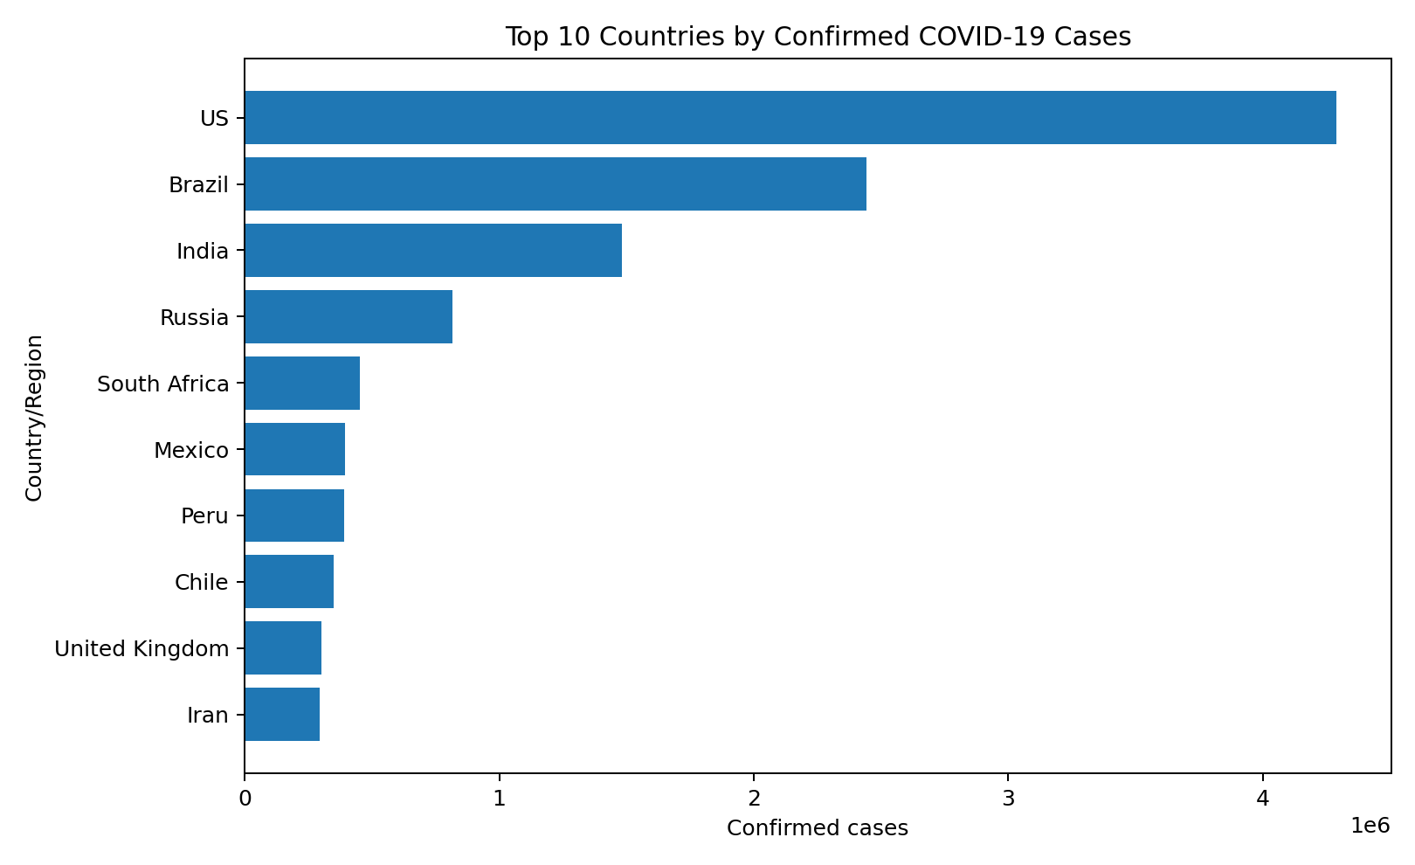
Figure 6.1: Top 10 countries by confirmed COVID-19 cases

6.2 Pie Chart
A pie chart can be used to show the share of confirmed cases by a small selected set of regions. For the full six-region comparison, the bar chart is more readable and is used below.

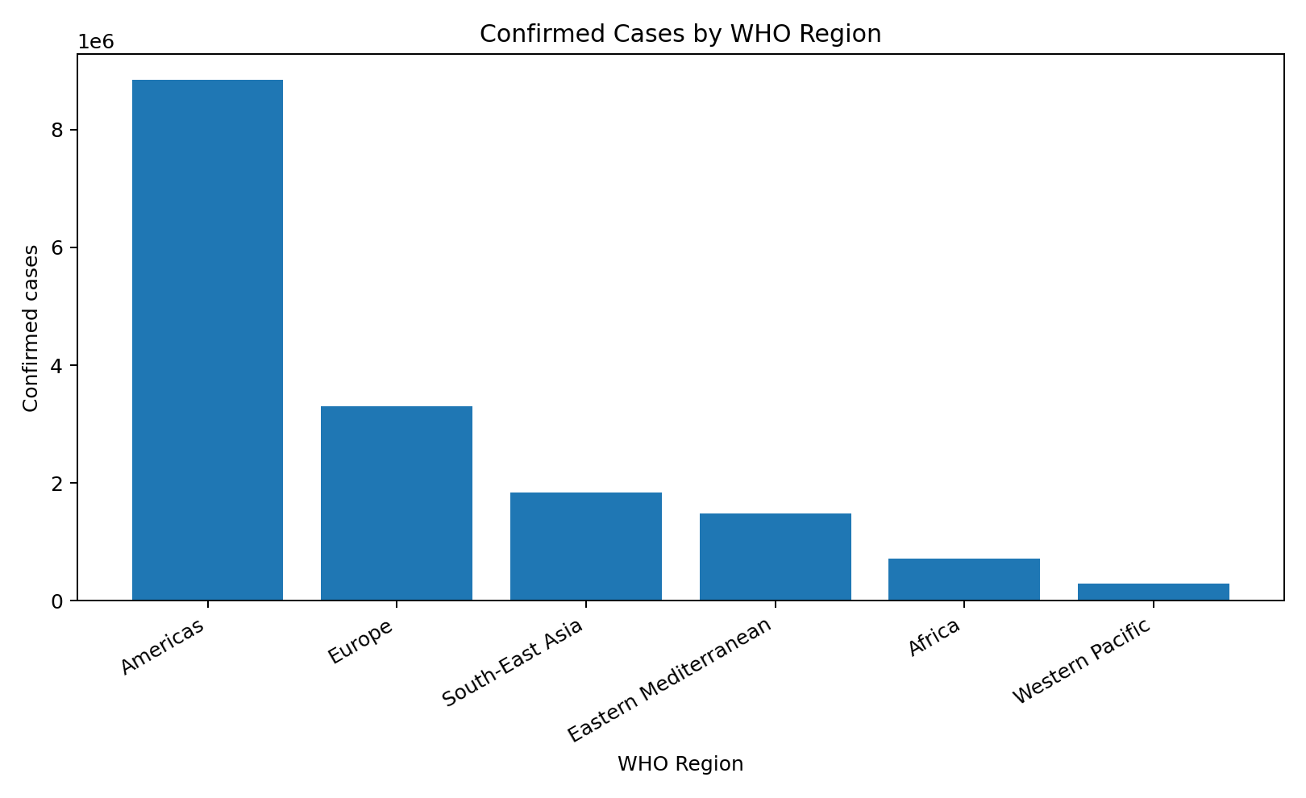
Figure 6.2: Confirmed cases by WHO region

6.3 Histogram
A histogram of confirmed cases can be used to inspect the distribution and skewness of country-level case counts. The distribution is expected to be highly uneven because a small number of countries have much larger case counts than many other countries.
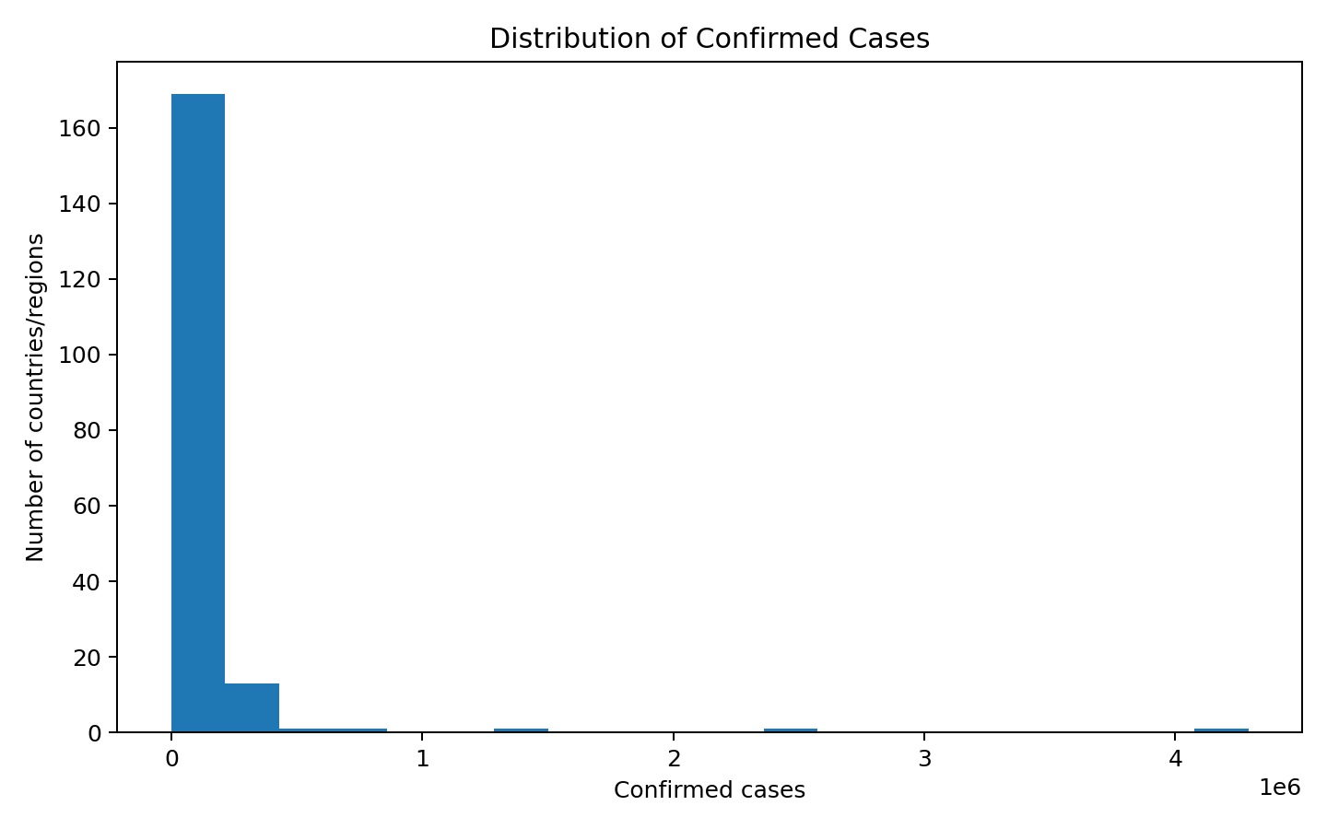
Figure 6.3: Distribution of confirmed cases

6.4 Box Plot
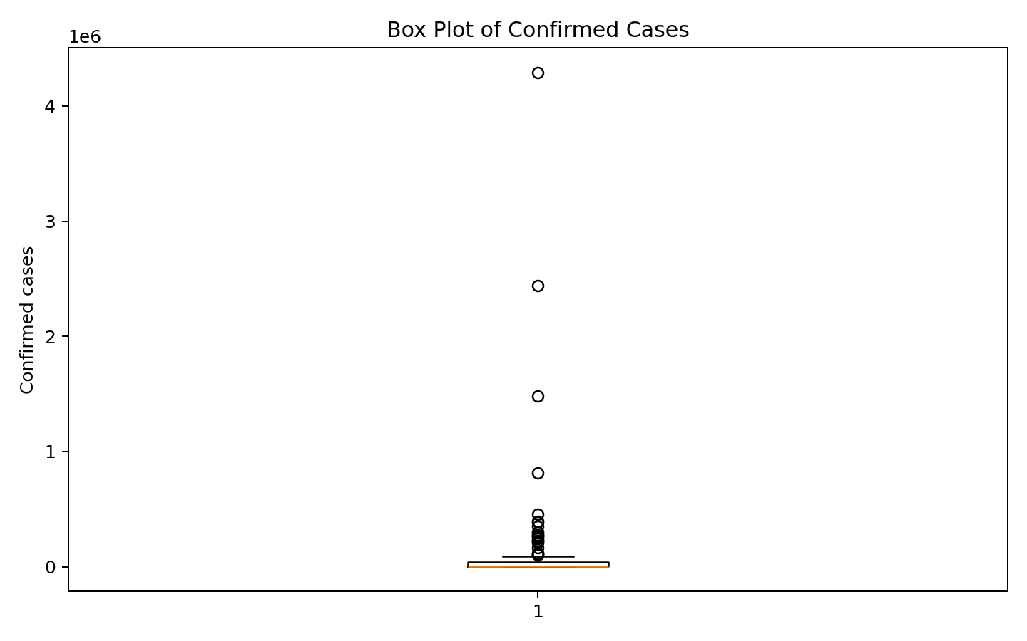
Figure 6.4: Box plot of confirmed cases

6.5 Line Chart
The supplied file contains weekly comparison fields rather than a full time-series history. Therefore, a true time-series line chart cannot be constructed from this dataset alone without adding data from other dates. The project does not invent such values.

6.6 Scatter Plot
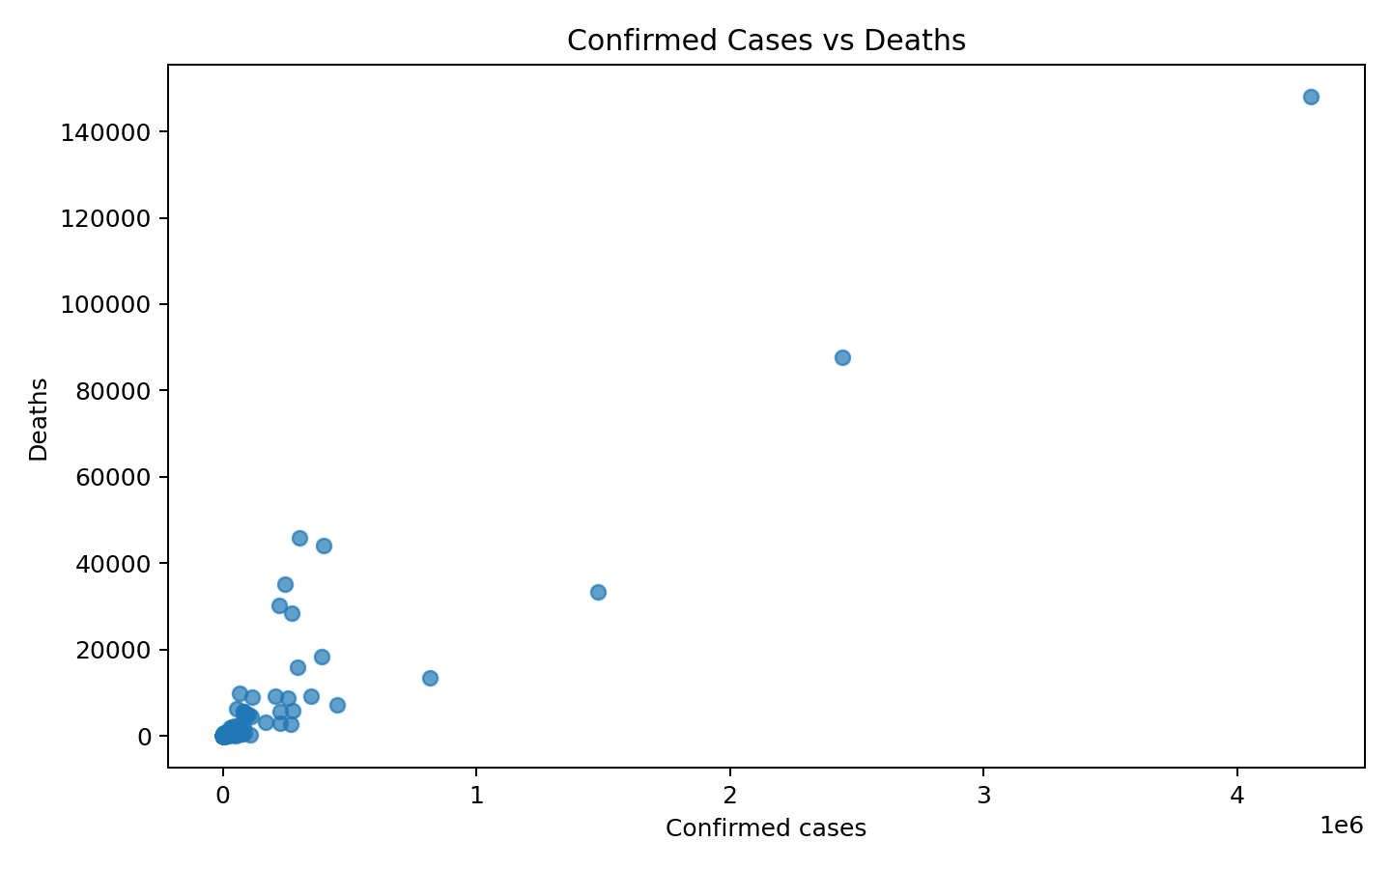
Figure 6.5: Confirmed cases vs deaths

6.7 Project-Specific Visualizations

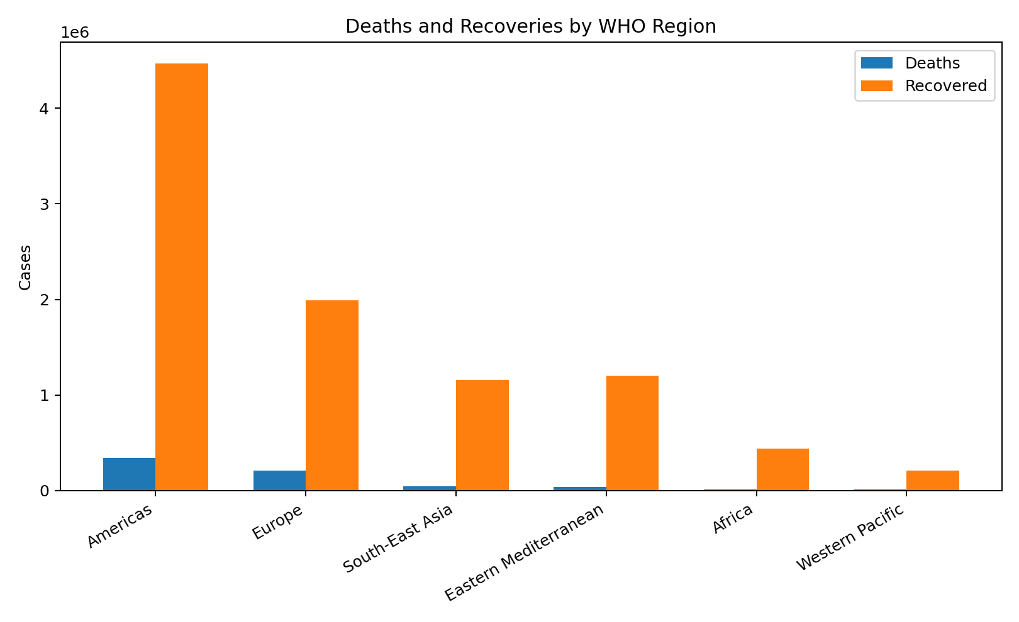
Figure 6.6: Deaths and recoveries by WHO region
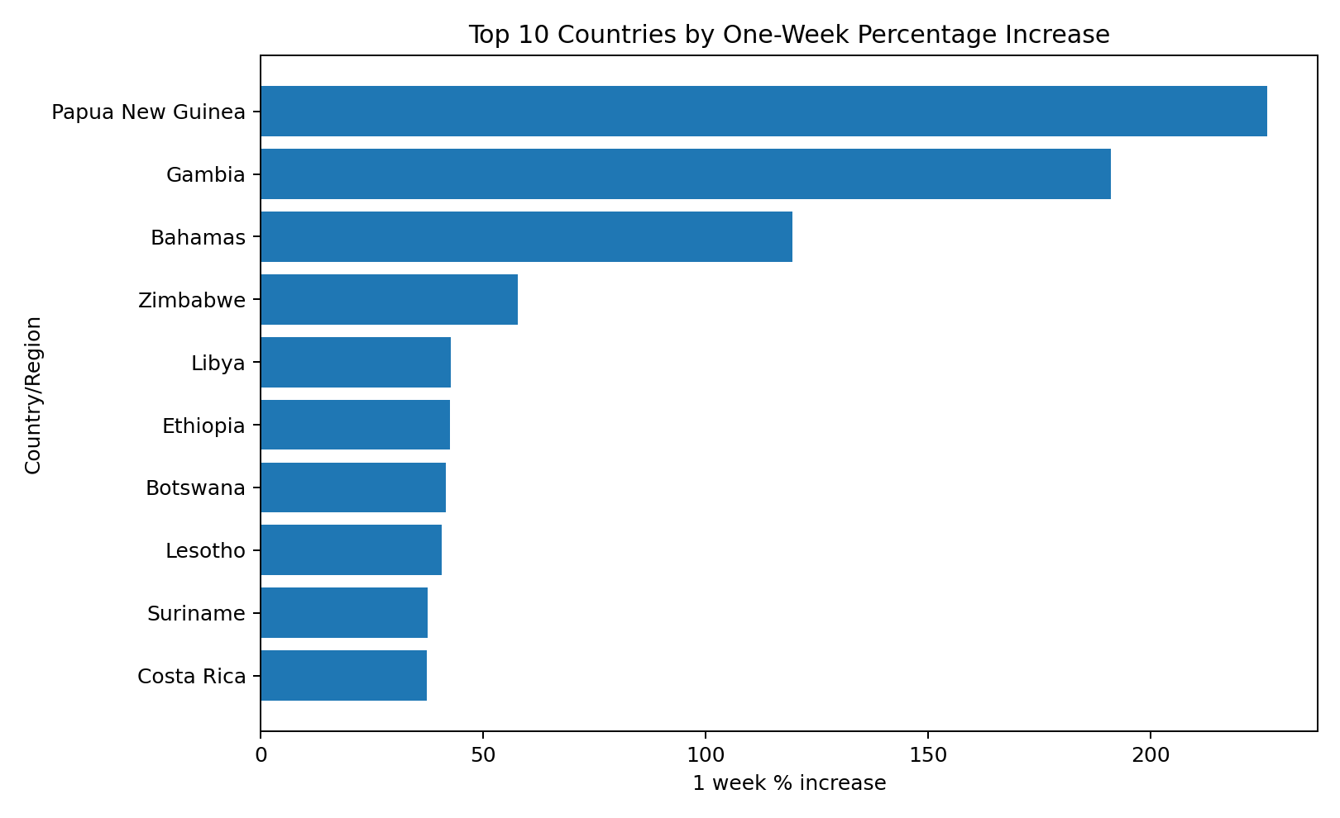
Figure 6.7: Top 10 countries by one-week percentage increase

6.8 Interpretation of Visualizations
The regional aggregation shows that the Americas have the largest confirmed-case total in the supplied dataset (8,839,286), followed by Europe (3,299,523) and South-East Asia (1,835,297). The country-level ranking shows the United States as the highest confirmed-case entry in this dataset. The scatter plot allows the relationship between confirmed cases and deaths to be visually examined, while the weekly percentage increase chart highlights countries with relatively high recent growth values.

CHAPTER 7 – ANALYSIS OF RESULTS

7.1 Evaluation Metrics
Since this is a descriptive analysis project, conventional predictive-model metrics such as accuracy, precision, recall and F1-score are not applicable. Instead, the project evaluates data completeness, descriptive totals, rankings, regional aggregates and visualization-based interpretation.

7.2 Experimental Results
Key results from the supplied dataset are summarized below.
Result | Value
Confirmed cases | 16,480,485
Deaths | 654,036
Recovered | 9,468,087
Active | 6,358,362
New cases | 228,693
New deaths | 5,415
New recovered | 174,623
Highest confirmed country | US (4,290,259)
Highest deaths country | US (148,011)
Highest recovered country | Brazil (1,846,641)

7.3 Result Interpretation
The analysis demonstrates substantial differences between countries and WHO regions. Confirmed cases, deaths, recoveries and active cases are not uniformly distributed. Regional grouping makes these differences easier to compare, while country ranking identifies records with the largest numerical values. The one-week change fields provide an additional measure of recent change available in the dataset.

7.4 Discussion
The project shows the importance of exploratory data analysis before drawing conclusions from a large dataset. Different indicators describe different aspects of the recorded situation, so a single column should not be interpreted in isolation. The analysis is descriptive and should not be treated as a medical or causal study.

CHAPTER 8 – OUTPUT SCREENSHOTS
The following figures represent the main outputs produced from the supplied dataset. In the final college submission, additional screenshots from the actual Python/Jupyter/VS Code execution environment may be inserted if required by the faculty.
Output: Top confirmed cases

Output: Regional confirmed cases
Output: Confirmed cases versus deaths

CHAPTER 9 – CONCLUSION AND FUTURE ENHANCEMENTS

9.1 Conclusion
This project successfully analyzes the supplied COVID-19 country-wise dataset containing 187 records and 15 attributes. The analysis covers data understanding, quality checking, descriptive statistics, country ranking, WHO-region aggregation and visualization. The dataset contains 16,480,485 confirmed cases, 654,036 deaths, 9,468,087 recovered cases and 6,358,362 active cases when summed across the supplied records. The visualizations make numerical differences easier to understand and provide a clear demonstration of practical data-analysis techniques.

9.2 Limitations
- The analysis is limited to the supplied dataset and its available fields.
- The file does not provide a complete date-by-date time series, so a full historical trend cannot be reconstructed from this file alone.
- The project is descriptive and does not establish causal relationships.
- The results should be interpreted as dataset-specific values rather than a complete real-world epidemiological assessment.

9.3 Future Enhancements
- Add date-wise historical COVID-19 records to build time-series analysis.
- Develop an interactive dashboard using Power BI, Tableau or a Python dashboard framework.
- Add correlation analysis and statistical testing.
- Compare trends across multiple time periods.
- If suitable time-series data are added, develop forecasting models with proper validation.

10 – REFERENCES
- Supplied COVID-19 country/region dataset: DAE DATA BASE (PROJECT).xls.
- Pandas documentation – data loading, cleaning and aggregation concepts.
- Matplotlib documentation – plotting and visualization concepts.
- Course material for Data Analysis Essentials.

11 – APPENDIX: SOURCE CODE
A compact reference implementation for the main analysis is provided below.
import pandas as pd
import matplotlib.pyplot as plt

# Load data
df = pd.read_csv("DAE DATA BASE (PROJECT).xls")

# Inspect data
print("Shape:", df.shape)
print(df.head())
print(df.dtypes)
print("Missing values:", df.isnull().sum().sum())
print("Duplicate rows:", df.duplicated().sum())

# Descriptive statistics
print(df.describe())

# Top 10 confirmed cases
top10 = df.nlargest(10, "Confirmed")
print(top10[["Country/Region", "Confirmed"]])

# Regional aggregation
region_summary = df.groupby("WHO Region")[
["Confirmed", "Deaths", "Recovered", "Active"]
].sum().sort_values("Confirmed", ascending=False)
print(region_summary)

# Bar chart
plt.figure(figsize=(10, 6))
plt.barh(top10["Country/Region"][::-1], top10["Confirmed"][::-1])
plt.xlabel("Confirmed Cases")
plt.ylabel("Country/Region")
plt.title("Top 10 Countries by Confirmed COVID-19 Cases")
plt.tight_layout()
plt.show()

# Scatter plot
plt.figure(figsize=(8, 5))
plt.scatter(df["Confirmed"], df["Deaths"])
plt.xlabel("Confirmed Cases")
plt.ylabel("Deaths")
plt.title("Confirmed Cases vs Deaths")
plt.tight_layout()
plt.show()

